Ver - 20200923

## Depart

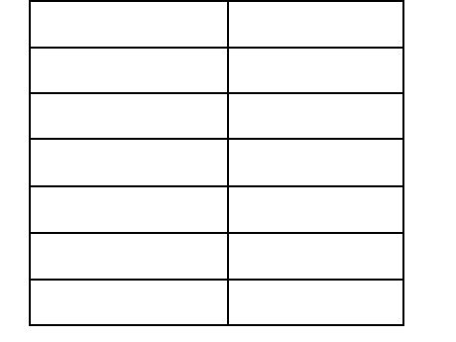

BBD852 BBD853 BBD854

14

4

16

|  |  |  |
| --- | --- | --- |
| **ment of Biochemical Engineering and Biotechnology** | **Course**  BBD451 | **Credits**  3 |
|  | BBD452 | 8 |
| **BBD451/452 – BTP : B.Tech Major Project (BB1)** | BBD851 | 6 |

**BBD851-854 – MTP : M.Tech Major Project (BB5) Semester 1, 2020-2021**

___________________________________________________________________

## Course description

The BTP or MTP is an important part of an undergraduate program in the department. It provides an excellent opportunity for the students to gain experience by applying and integrating the previously acquired knowledge from the courses in a major research/design project in Biochemical Engineering and Biotechnology.

## Course expectations

1. It is expected that the students would identify the project theme in consultation with the Faculty Mentors at the beginning of the semester and execute the project to its completion by end of the semester.
2. The execution of the project plan is largely the responsibility of the students. The initiative for keeping the project on schedule must come from students.
3. Students are required to write progress reports, give oral presentations and write a comprehensive final report documenting the project design, results/analysis, execution and conclusion.

## Plagiarism Policy

Plagiarism is the use of another person’s ideas or work without proper acknowledgement, thereby passing it off as one’s own. Acts of plagiarism are violations of academic policy of the Institute and the Honor Code signed by the student. Plagiarism will not be tolerated.

## Report/Presentation submission and Late Policy

There will be two **presentations** by all the students (one mid-term and the final). Students are required to submit the report and presentation before the announced deadlines. **Late** submission of reports or presentations will result in not being able to present and will not able to pass the course. All the students will be required to actively participate in the presentations being made by the entire class.

## Annexures

1. Guidelines for Report preparation (p. 2 – 13)
2. Guidelines for Presentation (p. 14)
3. Report and Presentation Submission Timelines (p. 15)
4. Evaluation Criteria (p. 16)
5. Evaluation Form to be used by the Review Committee (p. 17 – 18)

**Annexure 1**

## Guidelines for Report Preparation

The students are expected to submit a report for evaluation during mid-term and then again at the end of the Semester. The structure of both the **mid-term and final report** should be as given in the sample pages (please see the following pages). Research projects should contain motivation and research problem, research approach and work done and results obtained. Engineering design projects must contain the problem for which the engineering solution is proposed and users of the proposed solution, design, implementation and validation of the solution.

## Chapters

* Typically, the first chapter of your thesis should be the Introduction and this chapter will end with the objectives for your work. The second chapter should be Literature Survey. The next two chapters could be Materials and Methods, Results and Discussion. The final chapter should be Conclusions and future work.
* Depending on the nature of the project, other chapters could be concept design, programming logic, Applicability, etc.
* All Figures and Tables MUST be referred to in the text.
* The entire text should be both left and right justified, with uniform font size.
* All the references listed at the end should be referred to in the main text and in order
* No acronyms are to be used without giving their full form first.
* Font and Font size for report - Times New Roman 12
* Line spacing: 1.5

## Figures and Tables

* Each Figure should have a Figure Number and a caption *underneath* the Figure.
* Each Table should have a Table Number and a title *above* the Table.
* All Figures and Tables MUST be referred to in the text.
* There should be a List of Figures and a List of Tables after the Table of Contents.
* It is not sufficient to say that the ‘result is shown in Fig ...’. You must discuss each Figure and the conclusions that you draw from there. Same is the case with Tables.

## Equations and Variables

* Center all equations.
* All equations must have a number, which is right justified.
* All variable MUST be in italics.
* No number, parenthesis or mathematical symbol ( +, – etc.) should be in italics.
* All vectors and matrix notations should be in bold face and un-italicized.
* The rules mentioned above have to be followed in the text as well.
* The equations are referred to in the text simply by (no.) and not ‘Equation No.’.

## References

* All references should be in any journal format, providing names of authors, year of publication, title of the paper, journal name, volume number and particular page numbers. You may want to learn to use any bibliographic/reference management software.
* All the references listed at the end of the thesis should be referred to in the main text.

**< Title of BTP/MTP >**

## A PROJECT REPORT

*Submitted as part of BBDXXX B/MTech Major Project (BB1/5)*

*Submitted by:*

## Name of the Student Entry Number

*Guided by:*

## Name of the B/MTP Faculty Mentor



**DEPARTMENT OF BIOCHEMICAL ENGINEERING AND BIOTECHNOLOGY INDIAN INSTITUTE OF TECHNOLOGY DELHI**

## <month and year of submission>

**DECLARATION**

I certify that

* 1. the work contained in this report is original and has been done by me under the guidance of my supervisor(s).
  2. I have followed the guidelines provided by the Department in preparing the report.
  3. I have conformed to the norms and guidelines given in the Honor Code of Conduct of the Institute.
  4. whenever I have used materials (data, theoretical analysis, figures, and text) from other sources, I have given due credit to them by citing them in the text of the report and giving their details in the references. Further, I have taken permission from the copyright owners of the sources, whenever necessary.

*Signed by:*

## Name of the Student

**CERTIFICATE**

It is certified that the work contained in this report titled “Name of the project” is the original work done by <Name of the Student> and has been carried out under my supervision.

*Signed by:*

## Name of the Faculty Mentor

**Date:**

## ABSTRACT

Asdf asdf asdf asdf asdf

## TABLE OF CONTENTS

*Page*

Declaration ii

Certificate iii

Table of Contents iv

List of Tables v

List of Figures x

List of Abbreviations x

List of Equations x

## Chapter 1: Introduction 1

* 1. ABCDE ABCDE 1
  2. ABCDE ABCDE X

…

…

1.X OBJECTIVES X

## Chapter 2: Literature Survey X

* 1. ABCDE ABCDE X
  2. ABCDE ABCDE X

## Chapter 3: Materials and Methods X

* 1. ABCDE ABCDE X
  2. ABCDE ABCDE X

## Chapter 4: Results and Discussion X

* 1. ABCDE ABCDE X
  2. ABCDE ABCDE X

## Chapter 5: Summary and Conclusions X

* 1. SUMMARY X
  2. CONCLUDING REMARKS X

## References

**Appendix A** : ABCDE ABCDE ABCDE

**Appendix B** : ABCDE ABCDE ABCDE

|  |  |  |
| --- | --- | --- |
|  | **List of Tables** |  |
| **Table** | **Title** | **Page** |
| 3.1 | Bacterial strains and plasmids used | 10 |

|  |  |  |
| --- | --- | --- |
|  | **List of figures** |  |
| **Figure** | **Title** | **Page** |
| 3.1 | SDS-PAGE analysis of cleavage mixture | 10 |

## List of Abbreviations

**Abbreviation Description**

2,4-D 2,4-dichlorophenoxy acetic acid

LTR Long terminal repeats

MSG Malate Synthase

YMB Yeast Mannitol Broth

*(should be listed in alphabetical order)*

Chapter 1

# Introduction

asdf asdf asdf asdf

Chapter X

# References

Anderson, E. M., Haupt, A., Schiel, J. A., Chou, E., Machado, H. B., Strezoska, Ž., Lenger, S., Mcclelland, S., Birmingham, A. & Vermeulen, A. 2015. Systematic analysis of CRISPR–Cas9 mismatch tolerance reveals low levels of off-target activity. *Journal of Biotechnology,* 211**,** 56-65.

Bortesi, L. & Fischer, R. 2015. The CRISPR/Cas9 system for plant genome editing and beyond. *Biotechnology Advances,* 33**,** 41-52.

Cameron, P., Fuller, C. K., Donohoue, P. D., Jones, B. N., Thompson, M. S., Carter,

M. M., Gradia, S., Vidal, B., Garner, E. & Slorach, E. M. 2017. Mapping the genomic landscape of CRISPR–Cas9 cleavage. *Nature Methods,* 14**,** 600- 606.

Chuai, G.-H., Wang, Q.-L. & Liu, Q. 2017. *In silico* meets *in vivo*: towards computational CRISPR-based sgRNA design. *Trends in Biotechnology,* 35**,** 12-21.

Doench, J. G., Hartenian, E., Graham, D. B., Tothova, Z., Hegde, M., Smith, I., Sullender, M., Ebert, B. L., Xavier, R. J. & Root, D. E. 2014. Rational design of highly active sgRNAs for CRISPR-Cas9–mediated gene inactivation. *Nature Biotechnology,* 32**,** 1262-1267.

Friedman, J. H. 2001. Greedy function approximation: a gradient boosting machine.

*Annals of Statistics***,** 1189-1232.

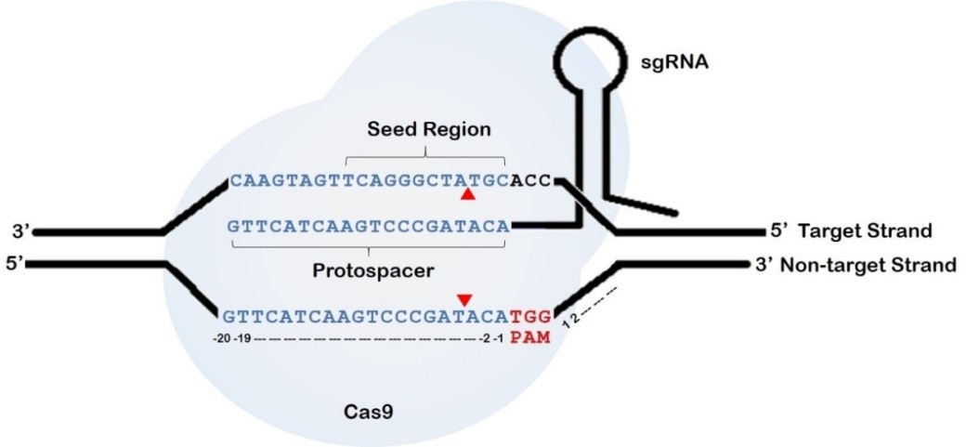

**Figure 1. Structure of CRISPR/Cas9 system.** It is a two component system. The 20 nucleotide protospacer sequence of CRISPR RNA guides the non-specific endonuclease, Cas9 to its target DNA within the genome. The HNH domain of Cas9 nuclease cleaves the target strand, whereas the RuvC domain introduces a break in the non-target strand. This results in a double strand break just 3 base pairs upstream of the NGG PAM (marked by red triangles).

**Table 1. Number of off-targets predicted to be accessible to CRISPR under *in vivo* conditions.** Using the *DNase*I hypersensitivity data, the targets and their corresponding off-targets are checked by *CRISPcut* for their residence in open chromatin region. The number of accessible off-targets for sgRNAs studied in HEK293T as predicted by *CRISPcut* is presented here.

**Target Number**

|  |  |  |  |
| --- | --- | --- | --- |
|  | | **Total** | **Accessible** |
| 5 | GGGAAAGACCCAGCATCCGTGGG | 10967 | 576 |
| 8 | GAACACAAAGCATAGACTGCGGG | 7948 | 267 |
| 9 | GGCCCAGACTGAGCACGTGATGG | 10155 | 667 |
| 10 | GGCACTGCGGCTGGAGGTGGGGG | 24502 | 2406 |

**Target Sequence**

**Number of off-­‐targets predicted by**

***CRISPcut***

## Guidelines to students for presentation

**Presentation instructions**: A student will be expected to deliver a concise overview of the research topic in the allotted time frame (say, 15-20 minutes). There will be 5- 10 minutes for questions and answers following the presentation. A student will be expected to complete this within the allotted time period, and no more. You will be cut off at the end of the allotted time, whether you are done or not.

**Guidelines and suggestions**: The presentation should generally follow the outline of the submitted report by the student. This should include a brief introduction that provides the frame of reference, the main body of presentation and a strong conclusion. The goal here should be to effectively get your message across. So the focus should be on science and not using unnecessary graphics.

**Slides**: The slides should be prepared in a manner to support what is being spoken. The following are general guidelines:

1. Keep the slides clear and simple.
2. Use graphs and figures wherever possible
3. Use minimum words for text and have titles for every slide
4. Use 18 or higher font size, using bold letters wherever required.
5. Do not use colors such as yellow, which are not easily visible. Do not make excessive use of colors.
6. The background should not reduce the visibility of the words/ tables/ figures you want to project.
7. Write the points (on which you wish to speak) and try to avoid writing full sentences.
8. Use standard language, symbols, notations and abbreviations.
9. Use standard units and write them properly. For example, write productivity as g/(L.h) and not as g/L/h. Write “h” for hour or hours (and not hr or hrs). Express enzyme activity in terms of International Units.
10. Write properly the names of microorganisms, genes, proteins etc.
11. Make tables such that independent variables appear in columns and dependent variables in rows.
12. Ensure that the abscissa and the ordinates in a figure are properly labeled and are legible.
13. The numbers you write should represent the accuracy of the measurement. That is, write significant figures. (You should know, for example, that 4.2 g is not the same as 4.20 g).
14. The material taken from elsewhere must be acknowledged at the bottom of the slide. This may be written in 12 or 14 font size.
15. Put a number on each slide, so that it can be referred to easily by the reviewers
16. During your talk, make specific reference to each of your slides
17. Avoid slides that merely repeat what you are saying

**Planning your presentation**: Once the slides are ready, practice your presentation repeatedly. Test your slides on screen to ensure that the slides are okay and the color schemes are not problematic. The slides

**Submission your presentation**: You will be responsible for submission of your presentation by 5 PM the day before your presentation. By submitting the presentation, you will be confirming that the work is your own and free of any plagiarism.

## Evaluation Criteria

**Grading Guidelines**

|  |  |  |  |
| --- | --- | --- | --- |
|  | **BBD451 / 452** | **BBD851 / 853** | **BBD852 / 854** |
| **Mid Semester** | 40% weightage | 40% weightage | 40% weightage |
| **Final** | 60% weightage | 60% weightage | 60% weightage  (30% external and 30% internal) |

## Evaluation Criteria

|  |  |  |
| --- | --- | --- |
|  | **BBD451/ 851/ 853** | **BBD452 / 852 / 854** |
| **Mid Semester** | * Understanding of Project * Literature survey * Initial work done (BBD451 / 851) | * Work done and results * Presentation of results and discussion * Planning of future work |
| **Final** | * Work done (methodology and initial results) * Future course of work * Planning of future work | * Overall understanding of project * Explanation of results * How the work done adds to the body of knowledge in the field |